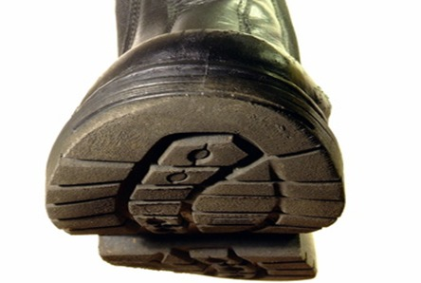 W

Weight loss

Boot camp

extreme

PDFIcon.jpgWord.jpg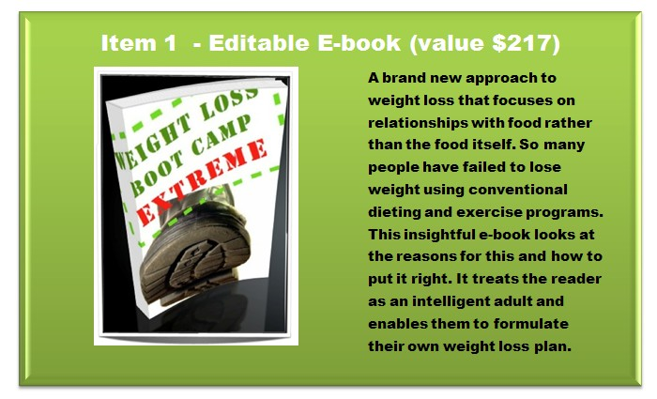

PowerPointIcon.jpg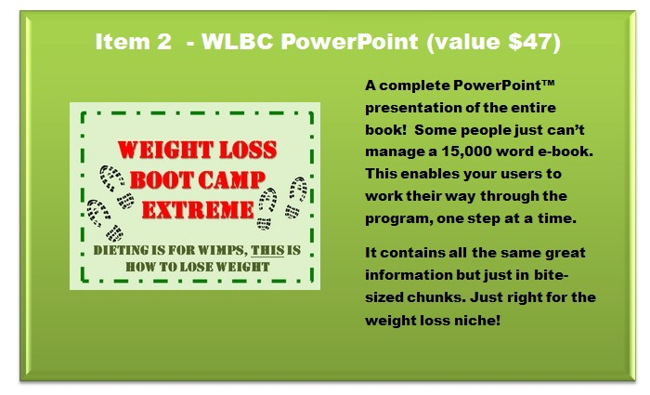

**MS PPT & PPTX Format**

PNGIcon.jpgJPGIcon.pngPSDIcon.jpgPDFIcon.jpg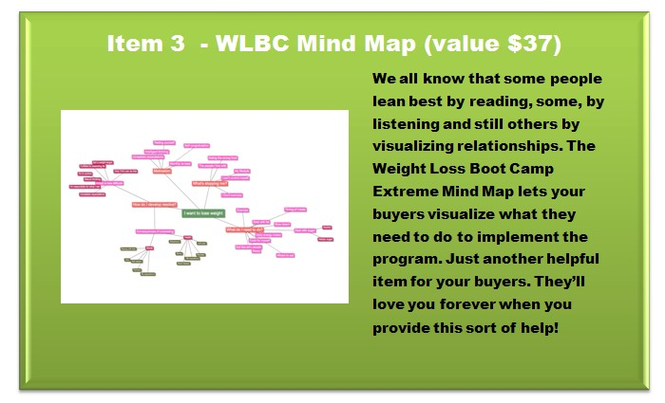

PDF, PSD, JPG & PNG Format

Weight Loss Boot Camp Extreme

**Wanna See Your Weight Do This?**

CSVIcon.jpgExcel.jpg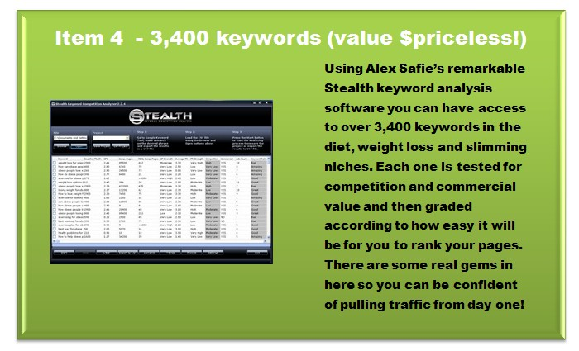

MS Excel & CSV Format

PNGIcon.jpgPSDIcon.jpgHTMLIcon.jpgJPGIcon.jpg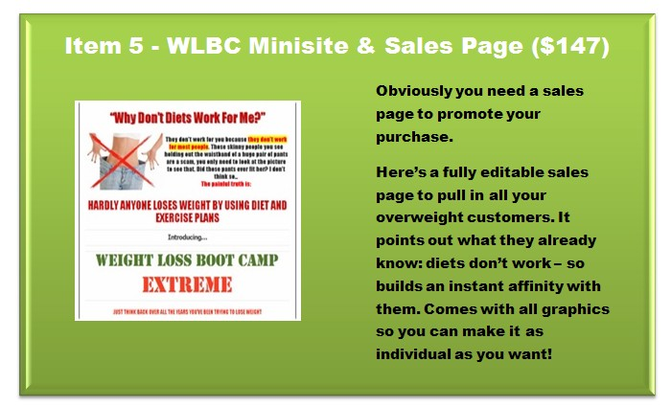

**If you’re serious about losing weight**

Weight

Loss

Boot

Camp

Extreme

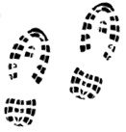

Total weight loss solution

HTML, PSD, PNG & JPG Format

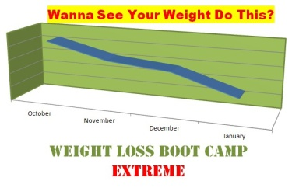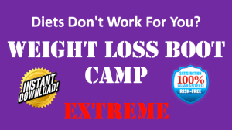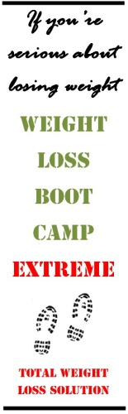JPGPSDPNGIcon.jpg

All the graphics you need to tweak and adjust your minisite to your own preference.

Available in three different formats – whatever works best for you!

JPG, PSD & PNG Format

t

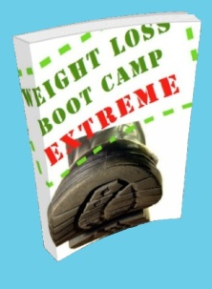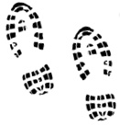

If diets just don’t work for you…

Weight loss Boot Camp

Extreme